CHANDIGARH GROUP OF COLLEGES



LANDRAN

**PROJECT REPORT ON MOVIE WEBSITE**

**NAME: MANAS RAJ**

**ROLL NO-2121357**

**SECTION: C1**

**COURSE: B. TECH**

**BRANCH: CSE**

**SUBMITTED TO: MRS. SUKHDEEP KAUR**

Name of project: MARVEL FANMADE MOVIE WEBSITE

Technologies used:

* HTML
* CSS
* INBUILT JAVASCRIPT

OPERATING SYSTEM : WINDOWS 11

TEAM MEMBERS : MANAS RAJ

*INDEX*

|  |  |
| --- | --- |
| *TITLE* | *PAGE NO.* |
| Abstract | 04 |
| Introduction | 05-09 |
| Source code | 09-40 |
| Screenshots | 41-43 |
| Conclusion | 44 |

**ABSTRACT**

Movies are made to entertain audiences, and movie websites are much the same. In order to get visitors’ attention and encourage them to see the movie, a website needs to give them what they are looking for and provide some entertainment at the same time. Today’s movie websites make it easy to take a couple minutes and watch a few trailers before deciding which movie to see.Because the purpose of movie websites is to pique interest and sell tickets, they generally include:

• Plenty of video, including trailers,

• Easy access to show times and online ticket purchasing,

• Cast bios and other general info.

It can be an interesting experience looking around at websites in particular industries to identify trends and see how they differ from those in other industries. In this article, we’ll take a look at the websites of major motion pictures to see what types of websites are being created. Movies are a big part of the entertainment industry, and in recent years their websites have become increasingly critical to their overall success.

It can be an interesting experience looking around at websites in particular industries to identify trends and see how they differ from those in other industries. In this article, we’ll take a look at the websites of major motion pictures to see what types of websites are being created. Movies are a big part of the entertainment industry, and in recent years their websites have become increasingly critical to their overall success.

**The Purpose Of Movie Websites**

Before getting into the details of specific movie websites and discussing current trends, it’s important first to consider the primary purpose of movie websites. Obviously, in order for a movie to be financially successful, it needs to do well at the box office, and today many moviegoers use the Internet to find movies to see and to buy tickets. Having things like trailers and other video clips helps to engage visitors and encourages them to find show times and buy tickets online.

*INTRODUCTION*

# What is HTML ?

**HTML** stands for Hyper Text Markup Language. It is used to design web pages using a markup language. HTML is the combination of Hypertext and Markup language. Hypertext defines the link between web pages. A markup language is used to define the text document within the tag which defines the structure of web pages. This language is used to annotate (make notes for the computer) text so that a machine can understand it and manipulate text accordingly. Most markup languages (e.g. HTML) are human-readable. The language uses tags to define what manipulation has to be done on the text.HTML is a markup language used by the browser to manipulate text, images, and other content, in order to display it in the required format. HTML was created by Tim Berners-Lee in 1991. The first-ever version of HTML was HTML 1.0, but the first standard version was HTML 2.0, published in 1995.

# Elements and Tags:

**HTML** predefined tags and elements which tell the browser how to properly display the content. Remember to include closing tags. If omitted, the browser applies the effect of the opening tag until the end of the page.

# What is HTML used for ?

HTML is used to create the structure of web pages that are displayed on the World Wide Web (www). It contains Tags and Attributes that are used to design the web pages. Also, we can link multiple pages using Hyperlinks.

***BASIC TAGS USED:***

# Division tag

The <div>tag defines a division or a section in an HTML document.The <div> tag is used as a container for HTML elements- which is then styled with CSS or manipulated with JavaScript.The <div> tag is easily styled by using the class or id attribute.

# Anchor tag:

# The <a> tag defines a hyperlink, which is used to link from one page to another.The most important attribute of the <a>element is the href attribute, which indicates the link's destination.

# Section tag:

# Section tag defines the section of documents such as chapters, headers, footers or any other sections. The section tag divides the content into section and subsections. The section tag is used when requirements of two headers or footers or any other section of documents needed. Section tag grouped the generic block of related contents. The main advantage of the section tag is, it is a semantic element, which describes its meaning to both browse

and developer.

# Nav tag:

The <nav> tag defines a set of navigation links. Notice that NOT all links of a document should be inside a <nav> element.The <nav> element is intended only for major block of navigation link.

**Span tag:**

# The span tag is a paired tag means it has both open(<) and closing (>) tags, and it is mandatory to close the tag. The span tag is used for the grouping of inline elements & this tag does not make any visual change by itself. span is very similar to the div tag, but div is a block-level tag and span is an inline tag. Other tags used are <p>,<br>,<ul>,<ol>,<li>,<link>,<h1> to

<h6>,<iframe>,<pre> etc.

**What is CSS ?**

**C**ascading **S**tyle **S**heets, fondly referred to as **CSS**, is a simply designed language intended to simplify the process of making web pages presentable. CSS allows you to apply styles to web pages. More importantly, CSS enables you to do this independent of the HTML that makes up each web page. It describes how a webpage should look: it prescribes colors, fonts, spacing, and much more. In short, you can make your website look however you want. CSS lets developers and designers define how it behaves, including how elements are positioned in the browser.While HTML uses tags, CSS uses rulesets. CSS is easy to learn and understand, but it provides powerful control over the presentation of an HTML document.

**Why CSS?**

* **CSS saves time:** You can write CSS once and reuse the same sheet in multiple HTML pages.
* **Easy Maintenance:** To make a global change simply change the style, and all elements in all the webpages will be updated automatically.
* **Search Engines:** CSS is considered a clean coding technique, which means search engines won’t have to struggle to “read” its content.
* **Superior styles to HTML:** CSS has a much wider array of attributes than HTML, so you can give a far better look to your HTML page in comparison to HTML attributes.
* **Offline Browsing:** CSS can store web applications locally with the help of an offline cache. Using this we can view offline websites

***MARVEL FANMADE MOVIE WEBSITE WEBSITE***

Website means the group HTML web pages and that is created to market/sell information/product/services.

From a bigger perspective, every website on the internet is the e- Commerce Website. It can be the platform, it can be a marketplace, it can be a portal, it can be apps, it can be an entertainment website, shopping website, online courses website and online degree college

Before getting into the details of specific movie websites and discussing current trends, it’s important first to consider the primary purpose of movie websites. Obviously, in order for a movie to be financially successful, it needs to do well at the box office, and today many moviegoers use the Internet to find movies to see and to buy tickets. Having things like trailers and other video clips helps to engage visitors and encourages them to find show times and buy tickets online.

**Visitor Expectations #**

The design, style and content of a movie website is generally meant to meet visitors’ expectations of that website. Visitors expect to find websites that are graphically rich, with audio and video as well. They expect something special, and entertainment value is often more important than the website being very accessible or fast-loading.

Visitors expect to be able to arrive on a movie website and determine within a few minutes if they want to see the movie. For this reason, trailers are key elements: they are almost always easy to find or automatically start when the home page loads.

**Trends Of Movie Websites #**

Among the sample movie websites discussed in this article, the following trends are apparent.

**1. FLASH #**

Most movie websites rely heavily on Flash for a dynamic and interactive experience. The audience of these websites typically expects to be entertained, so bells and whistles take priority, and heavy use of these elements is more acceptable than it would be on other types of websites.

**2. LARGE BACKGROUND IMAGES #**

In addition to Flash, larger photos and images play a huge role in creating attractive and interesting movie websites. Most movie websites make use of large images, in many cases as the background of the page.

**3. VIDEO/TRAILERS #**

It’s only natural to assume that the website of a movie would include some video. Almost all movie websites include a full trailer, and in some cases a few different trailers. Many websites put the trailer on the home page or a splash page, and the trailers often start without being prompted by the user.

While audio and video that automatically starts is usually considered a negative feature, because of their subject matter, movie websites are a bit different than the average website.

**3. SHORT PAGE LENGTH #**

It’s very common for movie websites to take up only the height of the screen, or just a bit more. It’s rare to find pages that are long and require a lot of vertical scrolling. With most websites being Flash-based or set against a large background image, the short page length keeps everything in view at all times.

**4. SOCIAL NETWORKING /MEDIA INTERACTION #**

Many movies have pages set up on Facebook and MySpace to take advantage of social networking opportunities. With the popularity of these social networking websites, especially among younger users, it’s no surprise that movie companies are seeing the value of getting involved. A bit more surprising is the number of movie websites that include links to encourage votes on social media websites such as Digg, Delicious, StumbleUpon and Reddit.

**5. FUN EXTRAS #**

Many movie websites, but not all, include more than just the typical movie and cast information along with the trailer. Games and activities are also very common. These elements can make the website more fun for visitors while also promoting the movie.

**SOURCE CODE**

**HOME PAGE:**

<!doctype html>

<html>

<head><meta charset="UTF-8">

<meta name="viewport" content="width=device-width, initial-scale=1.0">

<meta http-equiv="X-UA-Compatible" content="ie=edge">

<title>SUPERHERO</title>

</head>

<link href="https://fonts.googleapis.com/css?family=Baloo+Bhai&display=swap" rel="stylesheet">

<link rel="stylesheet" href="css/style.css">

<style>

.left {

display: inline-block;

/* border: 2px solid red; */

position: absolute;

left: 60px;

top: 20px;

}

.left div {

line-height: 19px;

font-size: 26px;

text-align: center;

}

.mid {

display: block;

width: 36%;

margin: 29px auto;

/* border: 2px solid green; */

}

.right {

position: absolute;

right: 34px;

top: 43px;

display: inline-block;

/* border: 2px solid yellow; */

}

.btn {

font-family:'Baloo Bhai', cursive;

margin: 0px 9px;

background-color: black;

color: white;

padding: 4px 14px;

border: 2px solid grey;

border-radius: 10px;

font-size: 20px;

cursor: pointer;

}

</style>

</head>

<body>

<style>

body{

background-image:

url('https://cdn.wallpapersafari.com/4/98/TU9WiB.jpg');

background-repeat:no-repeat;

background-attachment:fixed;

background-size:cover;

}

</style><br><br><br>

<center><img src="https://i.imgur.com/w3Q7c4v.png" width="300" height="50"></center>

<!-- Mid box for navbar -->

<div class="mid"><br> <br><br><br><br>

<a href="manas2.html" class="btn">HOME<span class="fas fa-chevron-right"></span></a>

<a href="https://twitter.com/i/flow/login" class="btn">TWITTER<span class="fas fa-chevron-right"></span></a>

<a href="https://www.instagram.com/" class="btn">INSTAGRAM<span class="fas fa-chevron-right"></span></a>

<a href="https://www.facebook.com/" class="btn">FACEBOOK<span class="fas fa-chevron-right"></span> </a>

</div></center>

<header class="right">

<button class="btn">Call Us Now<span class="fas fa-chevron-right"></span> </button>

<button class="btn">Email Us<span class="fas fa-chevron-right"></span> </button>

</div></header>

<center>

<br><br><br> <br><br><br><br><br><br><br><br><br><br><br><br><br><br><br><br><a href="index.html" class="btn">MCU<span class="fas fa-chevron-right"></span> </a></center>

</body>

</html>

**MAIN PAGE:**

<!DOCTYPE html>

<html lang="en">

<head>

<meta charset="UTF-8">

<meta http-equiv="X-UA-Compatible" content="IE=edge">

<meta name="viewport" content="width=device-width, initial-scale=1.0">

<title>marvel cinematic universe</title>

<!-- font awesome cdn link -->

<link rel="stylesheet" href="https://cdnjs.cloudflare.com/ajax/libs/font-awesome/5.15.4/css/all.min.css">

<!-- custom css file link -->

<link rel="stylesheet" href="css/style.css">

</head>

<body>

<!-- header section starts -->

<header class="header">

<a href="#" class="logo"><i class="fa fa-youtube-play" style="font-size:30px;color:red"</i> MARVEL </a>

<nav class="navbar">

<a href="#home">Home</a>

<a href="#Marvel movies">Marvel movies</a>

<a href="#about">About</a>

<a href="#Marvel series">Marvel series</a>

<a href="#Marvel comics">merchandise</a>

<a href="#Merchandise">Marvel Legends</a>

<a href="#book">Request a movie</a>

<p> </P><button class="btn"><input type="text" placeholder="search a movies" class="box"></button>

</nav>

<div id="menu-btn" class="fas fa-bars"></div>

</header>

<!-- header section ends -->

<!-- marvel cinematics universe section begins starts -->

<section class="home" id="home">

<div class="image">

<img src="https://wallpaperaccess.com/full/1112394.jpg" alt="">

</div>

<div class="content">

<h1>Marvel Cinematic Universe</h1>

<p>In Heros We Trust.</p>

<a href="https://www.youtube.com/c/marvelin" class="btn">Explore<span class="fas fa-chevron-right"></span> </a>

</div>

</section>

<!-- home section ends -->

<!-- icons section ends -->

<!-- marvel movies section starts -->

<section class="Marvel movies" id="Marvel movies">

<h1 class="heading"> Marvel <span>movies</span> </h1>

<div class="box-container">

<div class="box"><div class="share">

<div class="image">

<iframe width="380" height="200" src="https://www.youtube.com/embed/8ugaeA-nMTc" title="YouTube video player" frameborder="0" allow="accelerometer; autoplay; clipboard-write; encrypted-media; gyroscope; picture-in-picture" allowfullscreen></iframe>

</div>

<div class="content">

<div class="icon">

<font size="4">

<a href="#"> <i class="fas fa-calendar"></i>2nd may,2008 </a>

<a href="#"> <i class="fas fa-user"></i>Jon Favreau</a></font>

</div>

<h3>IRON MAN</h3>

<p><font size="3">Robert downey jr., Jon favreau, Gwyneth</font></p>

<a href="https://www.hotstar.com/in/movies/iron-man/1660000038" class="btn">watch now <span class="fas fa-chevron-right"></span> </a>

</div>

</div>

<div class="box">

<div class="image">

<iframe width="380" height="200" src="https://www.youtube.com/embed/H3vQbMSVlDw" title="YouTube video player" frameborder="0" allow="accelerometer; autoplay; clipboard-write; encrypted-media; gyroscope; picture-in-picture" allowfullscreen></iframe>

</div>

<div class="content">

<div class="icon">

<font size="4"> <a href="#"> <i class="fas fa-calendar"></i>13th june,2008 </a>

<a href="#"> <i class="fas fa-user"></i>Louis Leterrier</a></font>

</div>

<h3>THE INCREDIBLE HULK</h3>

<font size="3"> <p>Edward norton, Tim roth, Liv tyler</p></font>

<a href="https://www.primevideo.com/dp/amzn1.dv.gti.c2b41cbb-ccb9-4bec-91a3-68c79fb87156?autoplay=0&ref_=atv_cf_strg_wb" class="btn"> watch now <span class="fas fa-chevron-right"></span> </a>

</div>

</div>

<div class="box">

<div class="image">

<iframe width="380" height="200" src="https://www.youtube.com/embed/wKtcmiifycU" title="YouTube video player" frameborder="0" allow="accelerometer; autoplay; clipboard-write; encrypted-media; gyroscope; picture-in-picture" allowfullscreen></iframe>

</div>

<div class="content">

<div class="icon"> <font size="4">

<a href="#"> <i class="fas fa-calendar"></i>7th May,2010</a>

<a href="#"> <i class="fas fa-user"></i> Jon Favreau </a></font>

</div>

<h3>IRON MAN 2</h3>

<font size="3"> <p>Robert downey jr. , Don cheadle, Scarlett</p></font>

<a href="https://www.hotstar.com/in/movies/iron-man-2/1660000039" class="btn">watch now <span class="fas fa-chevron-right"></span> </a>

</div>

</div>

<div class="box">

<div class="image">

<iframe width="380" height="200" src="https://www.youtube.com/embed/JOddp-nlNvQ" title="YouTube video player" frameborder="0" allow="accelerometer; autoplay; clipboard-write; encrypted-media; gyroscope; picture-in-picture" allowfullscreen></iframe>

</div></div>

<div class="content">

<div class="icon"> <font size="4">

<a href="#"> <i class="fas fa-calendar"></i>6th may,2011</a>

<a href="#"> <i class="fas fa-user"></i>Kenneth Branagh</a></font>

</div>

<h3>THOR</h3>

<font size="3"> <p>Chris hemsworth, Natalle portman, Tom hiddleston</p></font>

<a href="https://www.hotstar.com/in/movies/thor/1660000044" class="btn">watch now <span class="fas fa-chevron-right"></span> </a>

</div>

</div>

<div class="box">

<div class="image">

<iframe width="380" height="200" src="https://www.youtube.com/embed/JerVrbLldXw?controls=0" title="YouTube video player" frameborder="0" allow="accelerometer; autoplay; clipboard-write; encrypted-media; gyroscope; picture-in-picture" allowfullscreen></iframe>

</div>

<div class="content">

<div class="icon"> <font size="4">

<a href="#"> <i class="fas fa-calendar"></i>22nd july,2011 </a>

<a href="#"> <i class="fas fa-user"></i>Joe Johnston</a></font>

</div>

<h3>CAPTAIN AMERICA:THE FIRST AVENGERS</h3>

<font size="3"> <p>Chris evans, Sebastian stan, Hayley atwell</p></font>

<a href="https://www.hotstar.com/in/movies/captain-america-the-first-avenger/1660000034" class="btn">watch now <span class="fas fa-chevron-right"></span> </a>

</div>

</div>

<div class="box">

<div class="image">

<iframe width="380" height="200" src="https://www.youtube.com/embed/NxUCAnAjHKo" title="YouTube video player" frameborder="0" allow="accelerometer; autoplay; clipboard-write; encrypted-media; gyroscope; picture-in-picture" allowfullscreen></iframe>

</div>

<div class="content">

<div class="icon"> <font size="4">

<a href="#"> <i class="fas fa-calendar"></i>4th may,2012 </a>

<a href="#"> <i class="fas fa-user"></i>Joss Whedon</a></font>

</div>

<h3>Marvel's The Avengers</h3>

<font size="3"> <p>Robert downey jr. ,Chris evans, Mark ruffalo</p></font>

<a href="https://www.hotstar.com/in/movies/marvels-the-avengers/1660000015" class="btn">watch now <span class="fas fa-chevron-right"></span> </a>

</div>

</div>

<div class="box">

<div class="image">

<iframe width="380" height="200" src="https://www.youtube.com/embed/zoWMW2O2rzc" title="YouTube video player" frameborder="0" allow="accelerometer; autoplay; clipboard-write; encrypted-media; gyroscope; picture-in-picture" allowfullscreen></iframe>

</div>

<div class="content">

<div class="icon"> <font size="4">

<a href="#"> <i class="fas fa-calendar"></i>3rd may,2013 </a>

<a href="#"> <i class="fas fa-user"></i>Shane Black</a></font>

</div>

<h3>IRON MAN 3</h3>

<font size="3"> <p>Robert downey jr. , Don cheadle,Ben Kingsley</p></font>

<a href="https://www.hotstar.com/in/movies/iron-man-3/1660000042" class="btn">watch now <span class="fas fa-chevron-right"></span> </a>

</div>

</div>

<div class="box">

<div class="image">

<iframe width="380" height="200" src="https://www.youtube.com/embed/biq0XGdmULc" title="YouTube video player" frameborder="0" allow="accelerometer; autoplay; clipboard-write; encrypted-media; gyroscope; picture-in-picture" allowfullscreen></iframe>

</div>

<div class="content">

<div class="icon"> <font size="4">

<a href="#"> <i class="fas fa-calendar"></i> 8th nov,2013 </a>

<a href="#"> <i class="fas fa-user"></i>Alan Taylor </a></font>

</div>

<h3>Thor:The Dark World</h3>

<font size="3"> <p>Chris hemsworth, Natalle portman, Tom hiddleston</p></font>

<a href="https://www.hotstar.com/in/movies/thor-the-dark-world/1260018142" class="btn">watch now <span class="fas fa-chevron-right"></span> </a>

</div>

</div>

<div class="box">

<div class="image">

<iframe width="380" height="200" src="https://www.youtube.com/embed/IcZZ-29FumQ" title="YouTube video player" frameborder="0" allow="accelerometer; autoplay; clipboard-write; encrypted-media; gyroscope; picture-in-picture" allowfullscreen></iframe>

</div>

<div class="content">

<div class="icon"> <font size="4">

<a href="#"> <i class="fas fa-calendar"></i>4th April,2014 </a>

<a href="#"> <i class="fas fa-user"></i>Russo Brothers</a></font>

</div>

<h3>Captain America:The Winter Soldier</h3>

<font size="3"> <p>Sebastian stan, Antony mackie, Chris evans</p></font>

<a href="https://www.hotstar.com/in/movies/captain-america-the-winter-soldier/1260016410" class="btn">watch now <span class="fas fa-chevron-right"></span> </a>

</div>

</div>

<div class="box">

<div class="image">

<iframe width="380" height="200" src="https://www.youtube.com/embed/ZqbojqBkYzY" title="YouTube video player" frameborder="0" allow="accelerometer; autoplay; clipboard-write; encrypted-media; gyroscope; picture-in-picture" allowfullscreen></iframe>

</div>

<div class="content">

<div class="icon"> <font size="4">

<a href="#"> <i class="fas fa-calendar"></i>1st auguest,2014 </a>

<a href="#"> <i class="fas fa-user"></i>James Gunn</a></font>

</div>

<h3>Guardians of The Galaxy</h3>

<font size="3"> <p>Chris pratt,Karen gillan,Zoe saldana</p></font>

<a href="https://www.hotstar.com/in/movies/guardians-of-the-galaxy/1260018294" class="btn">watch now <span class="fas fa-chevron-right"></span> </a>

</div>

</div>

<div class="box">

<div class="image">

<iframe width="380" height="200" src="https://www.youtube.com/embed/ZeIa7xGDq8c" title="YouTube video player" frameborder="0" allow="accelerometer; autoplay; clipboard-write; encrypted-media; gyroscope; picture-in-picture" allowfullscreen></iframe>

</div>

<div class="content">

<div class="icon"> <font size="4">

<a href="#"> <i class="fas fa-calendar"></i>1st May,2015 </a>

<a href="#"> <i class="fas fa-user"></i>Joss Whedon</a></font>

</div>

<h3>Avengers:Age of Ultron</h3>

<font size="3"> <p>Robert downey jr. ,Elizabeth Olsen,Chris Evans</p></font>

<a href="https://www.hotstar.com/in/movies/marvels-avengers-age-of-ultron/1260018315" class="btn">watch now <span class="fas fa-chevron-right"></span> </a>

</div>

</div>

<div class="box">

<div class="image">

<iframe width="380" height="200" src="https://www.youtube.com/embed/aunT6UaU99Q" title="YouTube video player" frameborder="0" allow="accelerometer; autoplay; clipboard-write; encrypted-media; gyroscope; picture-in-picture" allowfullscreen></iframe>

</div>

<div class="content">

<div class="icon"> <font size="4">

<a href="#"> <i class="fas fa-calendar"></i>17th July,2015</a>

<a href="#"> <i class="fas fa-user"></i>Peyton Reed</a></font>

</div>

<h3>ANT-MAN</h3>

<font size="3"> <p>Paul Rudd, Evangeline Lilly,Michael Douglas</p></font>

<a href="https://www.hotstar.com/in/movies/antman/1260018141" class="btn">watch now <span class="fas fa-chevron-right"></span> </a>

</div>

</div>

<div class="box">

<div class="image">

<iframe width="380" height="200" src="https://www.youtube.com/embed/IxxmvrrSSNQ" title="YouTube video player" frameborder="0" allow="accelerometer; autoplay; clipboard-write; encrypted-media; gyroscope; picture-in-picture" allowfullscreen></iframe>

</div>

<div class="content">

<div class="icon"> <font size="4">

<a href="#"> <i class="fas fa-calendar"></i>6th May,2016 </a>

<a href="#"> <i class="fas fa-user"></i>Russo Brothers</a></font>

</div>

<h3>Captain America:Civil War</h3>

<font size="3"> <p>Chris Evans,RDJ,Elizabeth Olsen,Tom Holland</p></font>

<a href="https://www.hotstar.com/in/movies/captain-america-civil-war/1260016768" class="btn">watch now <span class="fas fa-chevron-right"></span> </a>

</div>

</div>

<div class="box">

<div class="image">

<iframe width="380" height="200" src="https://www.youtube.com/embed/B4aI54T79Ik" title="YouTube video player" frameborder="0" allow="accelerometer; autoplay; clipboard-write; encrypted-media; gyroscope; picture-in-picture" allowfullscreen></iframe>

</div>

<div class="content">

<div class="icon"> <font size="4">

<a href="#"> <i class="fas fa-calendar"></i> 4th Nov,2016</a>

<a href="#"> <i class="fas fa-user"></i>Scott Derrickson </a></font>

</div>

<h3>Doctor Strange</h3>

<font size="3"> <p>Benedict Cumberbatch, Rachel McAdams, Benedict Wong</p></font>

<a href="https://www.youtube.com/watch?v=U_u8MzNZ7TA" class="btn">watch now <span class="fas fa-chevron-right"></span> </a>

</div>

</div>

<div class="box">

<div class="image">

<iframe width="380" height="200" src="https://www.youtube.com/embed/wUn05hdkhjM" title="YouTube video player" frameborder="0" allow="accelerometer; autoplay; clipboard-write; encrypted-media; gyroscope; picture-in-picture" allowfullscreen></iframe>

</div>

<div class="content">

<div class="icon"> <font size="4">

<a href="#"> <i class="fas fa-calendar"></i>5th May,2017 </a>

<a href="#"> <i class="fas fa-user"></i>James Gunn</a></font>

</div>

<h3>Guardians of The Galaxy vol.2</h3>

<font size="3"> <p>Chris pratt,Karen gillan,Zoe saldana</p></font>

<a href="https://www.hotstar.com/in/movies/guardians-of-the-galaxy-vol-2/1260018295" class="btn">watch now <span class="fas fa-chevron-right"></span> </a>

</div>

</div>

<div class="box">

<div class="image">

<iframe width="380" height="200" src="https://www.youtube.com/embed/_GqEeagsSkY" title="YouTube video player" frameborder="0" allow="accelerometer; autoplay; clipboard-write; encrypted-media; gyroscope; picture-in-picture" allowfullscreen></iframe>

</div>

<div class="content">

<div class="icon"> <font size="4">

<a href="#"> <i class="fas fa-calendar"></i>7th July,2017 </a>

<a href="#"> <i class="fas fa-user"></i>Jon Watts</a></font>

</div>

<h3>SPIDER-MAN:Homecoming</h3>

<font size="3"> <p>Tom Holland,Zendaya,Marisa Tomei</p></font>

<a href="https://www.hotstar.com/in/movies/spiderman-homecoming/1260104626" class="btn">watch now <span class="fas fa-chevron-right"></span> </a>

</div>

</div>

<div class="box">

<div class="image">

<iframe width="380" height="200" src="https://www.youtube.com/embed/NNvt4OS7mhA" title="YouTube video player" frameborder="0" allow="accelerometer; autoplay; clipboard-write; encrypted-media; gyroscope; picture-in-picture" allowfullscreen></iframe>

</div>

<div class="content">

<div class="icon"> <font size="4">

<a href="#"> <i class="fas fa-calendar"></i>3rd Nov,2017 </a>

<a href="#"> <i class="fas fa-user"></i>Taika Waititi</a></font>

</div>

<h3>Thor:Ragnarok</h3>

<font size="3"> <p>Chris hemsworth, Natalle portman, Tom hiddleston</p></font>

<a href="https://www.hotstar.com/in/movies/thor-ragnarok/1660010577" class="btn">watch now <span class="fas fa-chevron-right"></span> </a>

</div>

</div>

<div class="box">

<div class="image">

<iframe width="380" height="200" src="https://www.youtube.com/embed/8HLovZBBebE" title="YouTube video player" frameborder="0" allow="accelerometer; autoplay; clipboard-write; encrypted-media; gyroscope; picture-in-picture" allowfullscreen></iframe>

</div>

<div class="content">

<div class="icon"> <font size="4">

<a href="#"> <i class="fas fa-calendar"></i>16th Feb,2018 </a>

<a href="#"> <i class="fas fa-user"></i>Ryan Coogler</a></font>

</div>

<h3>BLACK PANTHER</h3>

<font size="3"> <p>Chadwick Boseman, Michael jordan, Letitia Wright</p></font>

<a href="https://www.hotstar.com/in/movies/black-panther/1660010672" class="btn">watch now <span class="fas fa-chevron-right"></span> </a>

</div>

</div>

<div class="box">

<div class="image">

<iframe width="380" height="200" src="https://www.youtube.com/embed/twXfolLOiHc" title="YouTube video player" frameborder="0" allow="accelerometer; autoplay; clipboard-write; encrypted-media; gyroscope; picture-in-picture" allowfullscreen></iframe>

</div>

<div class="content">

<div class="icon"> <font size="4">

<a href="#"> <i class="fas fa-calendar"></i>27th April</a>

<a href="#"> <i class="fas fa-user"></i>Russo Brothers</a></font>

</div>

<h3>Avengers:Infinity War</h3>

<font size="3"> <p>Robert downey jr. , Chris hemsworth,Chadwick Boseman</p></font>

<a href="https://www.hotstar.com/in/movies/avengers-infinity-war/1660010677" class="btn">watch now <span class="fas fa-chevron-right"></span> </a>

</div>

</div>

<div class="box">

<div class="image">

<iframe width="380" height="200" src="https://www.youtube.com/embed/MJkn2hTQtZs" title="YouTube video player" frameborder="0" allow="accelerometer; autoplay; clipboard-write; encrypted-media; gyroscope; picture-in-picture" allowfullscreen></iframe>

</div>

<div class="content">

<div class="icon"> <font size="4">

<a href="#"> <i class="fas fa-calendar"></i>6th July,2018 </a>

<a href="#"> <i class="fas fa-user"></i>Peyton Reed</a></font>

</div>

<h3>Ant-Man And The Wasp</h3>

<font size="3"> <p>Paul Rudd, Evangeline Lilly,Michael Douglas</p></font>

<a href="https://www.hotstar.com/in/movies/antman-and-the-wasp/1660010696" class="btn">watch now <span class="fas fa-chevron-right"></span> </a>

</div>

</div>

<div class="box">

<div class="image">

<iframe width="380" height="200" src="https://www.youtube.com/embed/QyUE4xibgAM" title="YouTube video player" frameborder="0" allow="accelerometer; autoplay; clipboard-write; encrypted-media; gyroscope; picture-in-picture" allowfullscreen></iframe>

</div>

<div class="content">

<div class="icon"> <font size="4">

<a href="#"> <i class="fas fa-calendar"></i>8th March,2019 </a>

<a href="#"> <i class="fas fa-user"></i>Anna Boden</a></font>

</div>

<h3>Captain Marvel</h3>

<font size="3"> <p>Brie Larson, Samuel Jackson, Gemma Chan</p></font>

<a href="https://www.hotstar.com/in/movies/captain-marvel/1260014878" class="btn">watch now <span class="fas fa-chevron-right"></span> </a>

</div>

</div>

<div class="box">

<div class="image">

<iframe width="380" height="200" src="https://www.youtube.com/embed/LPhqL4DqzBg" title="YouTube video player" frameborder="0" allow="accelerometer; autoplay; clipboard-write; encrypted-media; gyroscope; picture-in-picture" allowfullscreen></iframe>

</div>

<div class="content">

<div class="icon"> <font size="4">

<a href="#"> <i class="fas fa-calendar"></i>26th April ,2019</a>

<a href="#"> <i class="fas fa-user"></i>Russo Brothers</a></font>

</div>

<h3>Avengers:Endgame</h3>

<font size="3"> <p>RDJ,Paul Rudd,Chris Evans,Jose Brolin</p></font>

<a href="https://www.hotstar.com/in/movies/avengers-endgame/1260013556" class="btn">watch now <span class="fas fa-chevron-right"></span> </a>

</div>

</div>

<div class="box">

<div class="image">

<iframe width="380" height="200" src="https://www.youtube.com/embed/VJfBMtAmvbw" title="YouTube video player" frameborder="0" allow="accelerometer; autoplay; clipboard-write; encrypted-media; gyroscope; picture-in-picture" allowfullscreen></iframe>

</div>

<div class="content">

<div class="icon"> <font size="4">

<a href="#"> <i class="fas fa-calendar"></i>26th june,2019 </a>

<a href="#"> <i class="fas fa-user"></i>Jon Watts </a></font>

</div>

<h3>Spider-Man:Far From Home</h3>

<font size="3"> <p> Tom Holland , Peter Parker, zendaya</p></font>

<a href="https://www.netflix.com/in/title/81055822?source=35" class="btn">watch now <span class="fas fa-chevron-right"></span> </a>

</div>

</div>

<div class="box">

<div class="image">

<iframe width="380" height="200" src="https://www.youtube.com/embed/K7J9fvGyAm4" title="YouTube video player" frameborder="0" allow="accelerometer; autoplay; clipboard-write; encrypted-media; gyroscope; picture-in-picture" allowfullscreen></iframe>

</div>

<div class="content">

<div class="icon"> <font size="4">

<a href="#"> <i class="fas fa-calendar"></i>29th June,2021 </a>

<a href="#"> <i class="fas fa-user"></i>Cate Shortland</a></font>

</div>

<h3>BLACK WIDOW</h3>

<font size="3"> <p>Scarlett Johansson,Florence Pugh, David Harbour</p></font>

<a href="https://www.hotstar.com/in/movies/black-widow/1260067485" class="btn">watch now <span class="fas fa-chevron-right"></span> </a>

</div>

</div>

<div class="box">

<div class="image">

<iframe width="380" height="200" src="https://www.youtube.com/embed/6Vddfmcm4uY" title="YouTube video player" frameborder="0" allow="accelerometer; autoplay; clipboard-write; encrypted-media; gyroscope; picture-in-picture" allowfullscreen></iframe>

</div>

<div class="content">

<div class="icon"> <font size="4">

<a href="#"> <i class="fas fa-calendar"></i>3rd sept,2021</a>

<a href="#"> <i class="fas fa-user"></i>Destin Deniel</a></font>

</div>

<h3>Shang-chi And The Legend of Ten Rings</h3>

<font size="3"> <p>Simu Liu, Awkwafina,Stephanie Hsu</p></font>

<a href="https://www.hotstar.com/in/movies/shangchi-and-the-legend-of-the-ten-rings/1260072682" class="btn">watch now <span class="fas fa-chevron-right"></span> </a>

</div>

</div>

<div class="box">

<div class="image">

<iframe width="380" height="200" src="https://www.youtube.com/embed/hzerUSVFxlg" title="YouTube video player" frameborder="0" allow="accelerometer; autoplay; clipboard-write; encrypted-media; gyroscope; picture-in-picture" allowfullscreen></iframe>

</div>

<div class="content">

<div class="icon"> <font size="4">

<a href="#"> <i class="fas fa-calendar"></i>5th Nov, 2021 </a>

<a href="#"> <i class="fas fa-user"></i>Chloe Zhao</a></font>

</div>

<h3>The Eternals</h3>

<font size="3"> <p>Harry Styles, Angelina Jolie,Haris Patel</p></font>

<a href="https://www.hotstar.com/in/movies/eternals/1260077949" class="btn">watch now <span class="fas fa-chevron-right"></span> </a>

</div>

</div>

<div class="box">

<div class="image">

<iframe width="380" height="200" src="https://www.youtube.com/embed/ei7R345Cjo0" title="YouTube video player" frameborder="0" allow="accelerometer; autoplay; clipboard-write; encrypted-media; gyroscope; picture-in-picture" allowfullscreen></iframe>

</div>

<div class="content">

<div class="icon"> <font size="4">

<a href="#"> <i class="fas fa-calendar"></i> 17th Dec, 2021</a>

<a href="#"> <i class="fas fa-user"></i>Jon Watts </a></font>

</div>

<h3>Spider-Man:No Way Home</h3>

<font size="3"> <p>Tom Holland, Tobey Maguire,Andrew garfield</p></font>

<a href="https://www.netflix.com/in/title/81465707?source=35" class="btn">watch now <span class="fas fa-chevron-right"></span> </a>

</div>

</div>

<div class="box">

<div class="image">

<iframe width="380" height="200" src="https://www.youtube.com/embed/-mjWrrKgwJM" title="YouTube video player" frameborder="0" allow="accelerometer; autoplay; clipboard-write; encrypted-media; gyroscope; picture-in-picture" allowfullscreen></iframe>

</div>

<div class="content">

<div class="icon"> <font size="4">

<a href="#"> <i class="fas fa-calendar"></i>6th May,2022 </a>

<a href="#"> <i class="fas fa-user"></i>Scot Derrickson</a></font>

</div>

<h3>Doctor Strange In The Multiverse of Madeness</h3>

<font size="3"> <p>Benedict cumberbatch, Elizabeth Olsen,Benedict Wong</p></font>

<a href="https://www.hotstar.com/in/movies/doctor-strange-in-the-multiverse-of-madness/1260103761" class="btn">watch now <span class="fas fa-chevron-right"></span> </a>

</div>

</div>

<div class="box">

<div class="image">

<iframe width="380" height="200" src="https://www.youtube.com/embed/sFTD5vBfRGY" title="YouTube video player" frameborder="0" allow="accelerometer; autoplay; clipboard-write; encrypted-media; gyroscope; picture-in-picture" allowfullscreen></iframe>

</div>

<div class="content">

<div class="icon"> <font size="4">

<a href="#"> <i class="fas fa-calendar"></i>08th July,2022</a>

<a href="#"> <i class="fas fa-user"></i>Taika Waititi</a></font>

</div>

<h3>Thor Love And Thunder</h3>

<font size="3"> <p>Chris Hemsworth, Christian Bale, Natalie Portman</p></font>

<a href="#" class="btn">watch now <span class="fas fa-chevron-right"></span> </a>

</div>

</div>

</div>

</section>

<!-- marvel movies ends -->

<!-- about section starts -->

<section class="about" id="about">

<h1 class="heading"> <span>about</span> us </h1>

<div class="row">

<div class="image">

<img src="https://www.pixelstalk.net/wp-content/uploads/2016/04/Avengers-2-Age-of-Ultron-Logo-Wallpaper-HD.jpg" alt="" style="width:750px;height:450px;">

</div>

<div class="content">

<h3>We Are Marvel Fans.</h3>

<p>MarvelEntertainment website.<br>Biggest Fan Club in India <br>for a #marvel movie Brand Providing <br>Everything you need to know<br> about #marvel</p>

<audio controls autoplay>

<source src="Avengers - Bgm ! Marvel.ogg" type="audio/ogg">

<source src="Avengers - Bgm ! Marvel.mp3" type="audio/mpeg"></audio><br>

<a href="#" class="btn"> learn more <span class="fas fa-chevron-right"></span> </a>

</div>

</div>

</section>

<!-- about section ends -->

<!-- Marvel series starts -->

<section class="Marvel series" id="Marvel series">

<h1 class="heading">Marvel <span>series</span> </h1>

<div class="box-container">

<div class="box">

<div class="image">

<iframe width="380" height="200" src="https://www.youtube.com/embed/bIPWMzREBZA" title="YouTube video player" frameborder="0" allow="accelerometer; autoplay; clipboard-write; encrypted-media; gyroscope; picture-in-picture" allowfullscreen></iframe>

</div>

<div class="content">

<div class="icon">

<font size="4">

<a href="https://www.hotstar.com/in/tv/marvels-daredevil/1260091261/seasons/season-1/ss-9424?utm_source=gwa"> <i class="fas fa-film"></i>Season 1</a>

<a href="https://www.hotstar.com/in/tv/marvels-daredevil/1260091261/seasons/season-2/ss-9425?utm_source=gwa"> <i class="fas fa-film"></i>season 2</a>

<a href="https://www.hotstar.com/in/tv/marvels-daredevil/1260091261/seasons/season-3/ss-9426?utm_source=gwa"> <i class="fas fa-film"></i>season 3</a>

</font></div>

<h3>DareDevil</h3>

<p><font size="3">Charlie Cox, Deborah Ann Woll, Elden Helson</font></p>

<a href="https://www.hotstar.com/in/tv/marvels-daredevil/1260091261?utm_source=gwa" class="btn">watch now <span class="fas fa-chevron-right"></span> </a>

</div>

</div>

<div class="box">

<div class="image">

<iframe width="380" height="200" src="https://www.youtube.com/embed/7xE2AW0BTDI" title="YouTube video player" frameborder="0" allow="accelerometer; autoplay; clipboard-write; encrypted-media; gyroscope; picture-in-picture" allowfullscreen></iframe>

</div>

<div class="content">

<div class="icon">

<font size="4"> <a href="https://www.hotstar.com/in/tv/marvels-the-defenders/1260091248/list/episodes/t-1_2_3859?utm_source=gwa"> <i class="fas fa-film"></i>season 1 </a>

</font>

</div>

<h3>The Defenders</h3>

<font size="3"> <p>Charliee Cox,Finn Jonnes, Krysten Ritter</p></font>

<a href="https://www.hotstar.com/in/tv/marvels-the-defenders/1260091248?utm_source=gwa" class="btn"> watch now <span class="fas fa-chevron-right"></span> </a>

</div>

</div>

<div class="box">

<div class="image">

<iframe width="380" height="200" src="https://www.youtube.com/embed/Ch0wMWnXjeA" title="YouTube video player" frameborder="0" allow="accelerometer; autoplay; clipboard-write; encrypted-media; gyroscope; picture-in-picture" allowfullscreen></iframe>

</div>

<div class="content">

<div class="icon"> <font size="4">

<a href="https://www.hotstar.com/in/tv/wandavision/1260051344/list/episodes/t-1_2_3178?utm_source=gwa"> <i class="fas fa-film"></i>Season 1</a>

</font>

</div>

<h3>Wanda Vision</h3>

<font size="3"> <p>Elizabeth Olsen, Paul Bettany, Kathryn Hahn</p></font>

<a href="https://www.hotstar.com/in/tv/wandavision/1260051344?utm_source=gwa" class="btn">watch now <span class="fas fa-chevron-right"></span> </a></font>

</div>

</div>

<div class="box">

<div class="image">

<iframe width="380" height="200" src="https://www.youtube.com/embed/f1lJA95IzBM" title="YouTube video player" frameborder="0" allow="accelerometer; autoplay; clipboard-write; encrypted-media; gyroscope; picture-in-picture" allowfullscreen></iframe>

</div>

<div class="content">

<div class="icon"> <font size="4">

<a href="https://www.hotstar.com/in/tv/the-falcon-and-the-winter-soldier/1260055670/list/episodes/t-1_2_3249?utm_source=gwa"> <i class="fas fa-film"></i>season 1</a>

</font>

</div>

<h3>The Falcon and The Winter Soldier</h3>

<font size="3"> <p>Anthony Mackie,Wyatt Russell,Sebastian Stan</p></font>

<a href="https://www.hotstar.com/in/tv/the-falcon-and-the-winter-soldier/1260055670?utm_source=gwa" class="btn">watch now <span class="fas fa-chevron-right"></span> </a>

</div>

</div>

<div class="box">

<div class="image">

<iframe width="380" height="200" src="https://www.youtube.com/embed/h8Sw2Grt0JU" title="YouTube video player" frameborder="0" allow="accelerometer; autoplay; clipboard-write; encrypted-media; gyroscope; picture-in-picture" allowfullscreen></iframe>

</div>

<div class="content">

<div class="icon"> <font size="4">

<a href="https://www.hotstar.com/in/tv/loki/1260063451/list/episodes/t-1_2_3383?utm_source=gwa"> <i class="fas fa-film"></i>season1</a>

</font>

</div>

<h3>LOKI</h3>

<font size="3"> <p>Tom Hiddleston, Sophia Di Martino, Owen Wilson</p></font>

<a href="https://www.hotstar.com/in/tv/loki/1260063451?utm_source=gwa" class="btn">watch now <span class="fas fa-chevron-right"></span> </a>

</div>

</div>

<div class="box">

<div class="image">

<iframe width="380" height="200" src="https://www.youtube.com/embed/TMjhhctPPec" title="YouTube video player" frameborder="0" allow="accelerometer; autoplay; clipboard-write; encrypted-media; gyroscope; picture-in-picture" allowfullscreen></iframe>

</div>

<div class="content">

<div class="icon"> <font size="4">

<a href="https://www.hotstar.com/in/tv/hawkeye/1260073683/list/episodes/t-1_2_3637?utm_source=gwa"> <i class="fas fa-film"></i>season 1</a>

</font>

</div>

<h3>Hawkeye</h3>

<font size="3"> <p>Hailee Steinfeld, Jeremy Renner, Florence Pugh</p></font>

<a href="https://www.hotstar.com/in/tv/hawkeye/1260073683?utm_source=gwa" class="btn">watch now <span class="fas fa-chevron-right"></span> </a>

</div>

</div>

<div class="box">

<div class="image">

<iframe width="380" height="200" src="https://www.youtube.com/embed/nPE5ATJRLKk" title="YouTube video player" frameborder="0" allow="accelerometer; autoplay; clipboard-write; encrypted-media; gyroscope; picture-in-picture" allowfullscreen></iframe>

</div>

<div class="content">

<div class="icon"> <font size="4">

<a href="https://www.hotstar.com/in/tv/moon-knight/1260089681/list/episodes/t-1_2_3849?utm_source=gwa"> <i class="fas fa-film"></i>Season 1</a>

</font>

</div>

<h3>Moon Knight</h3>

<font size="3"> <p>Oscar Isaac, Ethan Hawke, May Calamawy</p></font>

<a href="https://www.hotstar.com/in/tv/moon-knight/1260089681?utm_source=gwa" class="btn">watch now <span class="fas fa-chevron-right"></span> </a>

</div>

</div>

<div class="box">

<div class="image">

<iframe width="380" height="200" src="https://www.youtube.com/embed/qHrgn6tc6hE" title="YouTube video player" frameborder="0" allow="accelerometer; autoplay; clipboard-write; encrypted-media; gyroscope; picture-in-picture" allowfullscreen></iframe>

</div>

<div class="content">

<div class="icon"> <font size="4">

<a href="https://www.hotstar.com/in/tv/ms-marvel/1260098459/list/episodes/t-1_2_3989?utm_source=gwa"> <i class="fas fa-film"></i>Season 1</a>

</font>

</div>

<h3>Ms. Marvel</h3>

<font size="3"> <p>Iman Vellani, Yasmeen Fletcher, Matt Lintz</p></font>

<a href="https://www.hotstar.com/in/tv/ms-marvel/1260098459?utm_source=gwa" class="btn">watch now <span class="fas fa-chevron-right"></span> </a>

</div>

</div>

</div>

</section>

<!--Marvel series ends -->

<!--Merchandise starts -->

<section class="Marvel comics" id="Marvel comics">

<h1 class="heading">Mercha<span>ndice</span> </h1>

<div class="box-container">

<div class="box">

<div class="image">

<img src="https://prod-img.thesouledstore.com/public/theSoul/uploads/catalog/product/1654324592_2790283.jpg?format=webp&w=1080&dpr=1.3" alt="" style="width:300px;height:400px;">

</div>

<div class="content">

<div class="icon">

<a href="https://www.thesouledstore.com/artists/marvel-official-merchandise"> <i class="fas fa-male"></i>T-shirts</a>

<a href="https://www.thesouledstore.com/artists/marvel-official-merchandise?page=1&filters=sort%7C%7CPOPULARITY%7C%7C%7Ccategory%7C%7C777%7C%7C%7Cprice%7C%7C399%7C2999"> <i class="fas fa-female"></i>T-shirts</a>

</div>

<a herf="https://www.thesouledstore.com/men"><h3>The Soulded Store</h3></a>

<p></p>

<a href="https://www.amazon.in/Marvel-Accessories/s?k=Marvel+Accessories" class="btn"><span class="fas fa-chevron-right">Accessories</span> </a>

</div>

</div>

<div class="box">

<div class="image">

<img src="https://prod-img.thesouledstore.com/public/theSoul/uploads/catalog/product/1653503607_7514608.jpg?format=webp&w=480&dpr=1.3" alt="" style="width:300px;height:400px;>

</div>

<div class="content">

<div class="icon"><font size="4">

<a href="https://shopdisney.in/shopdisney-merch.html?age=16319&franchise=17549%2C18944&gender=17567&jkjl=&&product_list_order=created"> <i class="fas fa-male"></i>Casual wear</a>

<a href="https://shopdisney.in/shopdisney-merch.html?age=16319&franchise=17549%2C18944&gender=17570&jkjl=&product_list_order=created"> <i class="fas fa-female"></i>Casual wear</a></font>

</div>

<a herf="https://shopdisney.in/"><h3>Disney.In</h3></a>

<a href="https://shopdisney.in/fashion-accessories.html" class="btn">Accessories<span class="fas fa-chevron-right"></span> </a>

</div>

</div>

<div class="box">

<div class="image">

<img src="https://images.bewakoof.com/t1080/black-beautymen-aop-t-shirt-464998-1656045579-1.jpg" alt="" style="width:325px;height:400px;>

</div>

<div class="content">

<div class="icon">

<font size="4"> <a href="https://www.bewakoof.com/marvel-merchandise/gender-men"> <i class="fas fa-male"></i>Casual wear</a>

<a href="https://www.bewakoof.com/marvel-merchandise/gender-women"> <i class="fas fa-female"></i>Casual wear </a></font>

</div>

<a herf="https://www.bewakoof.com/"> <h3>Bewakoof</h3></a>

<a href="https://www.bewakoof.com/marvel-merchandise/category-flip---flops---&---sliders--category-gym---bag--category-laptop---bag--category-sling---bag--category-momo---grip--category-protective---outdoor---mask--category-backpack--category-mobile---covers" class="btn">accessories<span class="fas fa-chevron-right"></span> </a>

</div>

</div>

</div>

</section>

<!-- Marvel merchandise ends -->

<!--Mearchandise section starts -->

<section class="Merchandise" id="Merchandise">

<h1 class="heading">Marvel<span> Legends</span> </h1>

<div class="box-container">

<div class="box">

<img src="https://hips.hearstapps.com/hmg-prod/images/stan-lee-arrives-at-the-premiere-of-disney-and-marvels-news-photo-950501274-1542049801.jpg?crop=1.00xw:0.512xh;0,0.0630xh&resize=1200:*" alt="" style="width:300px;height:320px;">

<h3>Stan Lee</h3>

<span>Comic writer</span><br>

<a href="https://en.wikipedia.org/wiki/Stan_Lee" class="btn">Wikipedia<span class="fas fa-chevron-right"></span> </a>

<div class="share">

<a href="https://www.facebook.com/realstanlee" class="fab fa-facebook-f"></a>

<a href="https://twitter.com/therealstanlee" class="fab fa-twitter"></a>

<a href="https://www.instagram.com/therealstanlee/?hl=en" class="fab fa-instagram"></a>

</div>

</div>

<div class="box">

<img src="https://static.wikia.nocookie.net/bakerstreet/images/7/78/Robert_Downey_Jr._%282022%29.jpg/revision/latest?cb=20220526032213" alt="" style="width:300px;height:320px;">

<h3>Robert Downey Jr.</h3>

<span>American Actor</span><br>

<a href="https://en.wikipedia.org/wiki/Robert_Downey_Jr." class="btn">Wikipedia<span class="fas fa-chevron-right"></span> </a>

<div class="share">

<a href="https://www.facebook.com/robertdowneyjr" class="fab fa-facebook-f"></a>

<a href="https://twitter.com/RobertDowneyJr?ref_src=twsrc%5Egoogle%7Ctwcamp%5Eserp%7Ctwgr%5Eauthor" class="fab fa-twitter"></a>

<a href="https://www.instagram.com/robertdowneyjr/" class="fab fa-instagram"></a>

</div>

</div>

<div class="box">

<img src="https://upload.wikimedia.org/wikipedia/commons/e/e8/Chadwick_Boseman_by_Gage_Skidmore_July_2017_%28cropped%29.jpg" alt="" style="width:300px;height:320px;">

<h3>Chadwick Boseman</h3>

<span>Actor</span><br>

<a href="https://en.wikipedia.org/wiki/Chadwick_Boseman" class="btn">Wikipedia<span class="fas fa-chevron-right"></span> </a>

<div class="share">

<a href="https://www.facebook.com/chadwickboseman" class="fab fa-facebook-f"></a>

<a href="https://twitter.com/chadwickboseman" class="fab fa-twitter"></a>

<a href="https://www.instagram.com/chadwickboseman/" class="fab fa-instagram"></a>

</div>

</div>

<div class="box">

<img src="https://upload.wikimedia.org/wikipedia/commons/3/33/Mark_Kassen%2C_Tony_C%C3%A1rdenas_and_Chris_Evans_%28cropped%29.jpg" alt="" style="width:300px;height:320px;">

<h3>Chris Evans</h3>

<span>American Actor</span><br>

<a href="https://en.wikipedia.org/wiki/Chris_Evans_(actor)" class="btn">Wikipedia<span class="fas fa-chevron-right"></span> </a>

<div class="share">

<a href="https://www.facebook.com/ChristopherEvansCaptainAmerica/" class="fab fa-facebook-f"></a>

<a href="https://twitter.com/chrisevans?lang=en" class="fab fa-twitter"></a>

<a href="https://www.instagram.com/chrisevans/?hl=en" class="fab fa-instagram"></a>

</div>

</div>

</div>

</section>

<!-- marvel legends section ends -->

<!-- request a movie section -->

<section class="book" id="book">

<h1 class="heading"> <span>Request A </span>Movies </h1>

<div class="row">

<div class="image">

<img src="https://cdn.wallpapersafari.com/60/90/ZFy8us.jpg" alt="" style="width:600px;height:400px;">

</div>

<form action="">

<h3>Request</h3>

<input type="text" placeholder="your name" class="box">

<input type="number" placeholder="your number" class="box">

<input type="email" placeholder="your email" class="box">

<input type="text" placeholder="movies name" class="box">

<input type="submit" value="send now" class="btn">

</form>

</div>

</section>

<!--marvel legends section ends -->

<!-- request section ends -->

<!-- footer section starts -->

<section class="footer">

<div class="box-container">

<div class="box">

<h3>quick links</h3>

<a href="#"> <i class="fas fa-chevron-right"></i> Home </a>

<a href="#"> <i class="fas fa-chevron-right"></i>Marvel movies </a>

<a href="#"> <i class="fas fa-chevron-right"></i> about </a>

<a href="#"> <i class="fas fa-chevron-right"></i>Marvel series </a>

<a href="#"> <i class="fas fa-chevron-right"></i>Request a movie </a>

<a href="#"> <i class="fas fa-chevron-right"></i>Marvel comics</a>

<a href="#"> <i class="fas fa-chevron-right"></i>Merchandise </a>

</div>

<div class="box">

<h3>contact info</h3>

<a href="#"> <i class="fas fa-phone"></i>7320842007 </a>

<a href="#"> <i class="fas fa-phone"></i>7782871545 </a>

<a href="#"> <i class="fas fa-envelope"></i> panjiyara45@gmai.com </a>

<a href="#"> <i class="fas fa-envelope"></i> rishushourya35@gmail.com</a>

<a href="#"> <i class="fas fa-map-marker-alt"></i> jasidih,deoghar,india -813101 </a>

</div>

<div class="box">

<h3>follow us</h3>

<a href="#"> <i class="fab fa-facebook-f"></i> facebook </a>

<a href="#"> <i class="fab fa-twitter"></i> twitter </a>

<a href="#"> <i class="fab fa-twitter"></i> twitter </a>

<a href="#"> <i class="fab fa-instagram"></i> instagram </a>

<a href="#"> <i class="fab fa-linkedin"></i> linkedin </a>

<a href="#"> <i class="fab fa-pinterest"></i> pinterest </a>

</div>

</div>

<div class="credit"> created by <span>Manas Raj Panjiyara.</span> | copyrights reserved.</div>

</section>

<!-- footer section ends -->

<!-- custom js file link -->

<script src="js/script.js"></script>

</body></html>

**SCREENSHORTS :**

**HOME PAGE :**

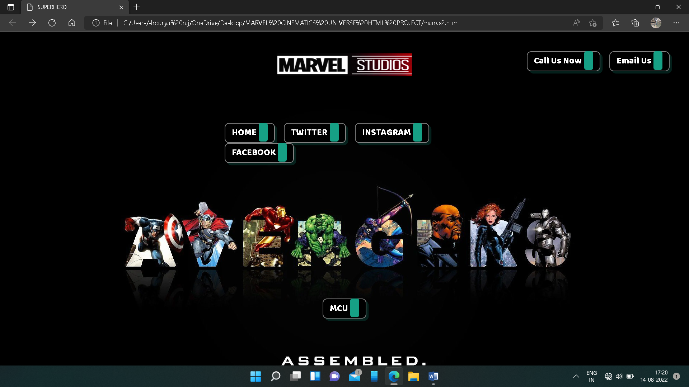

**MAIN PAGE :**

**HEADER AND HOME SECTION :**

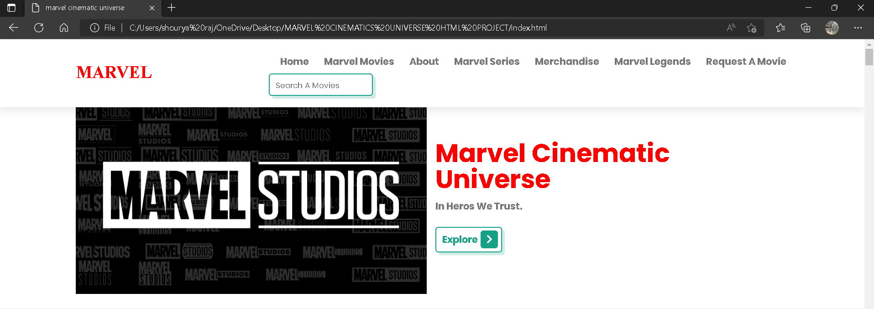

**MOVIE SECTION:**

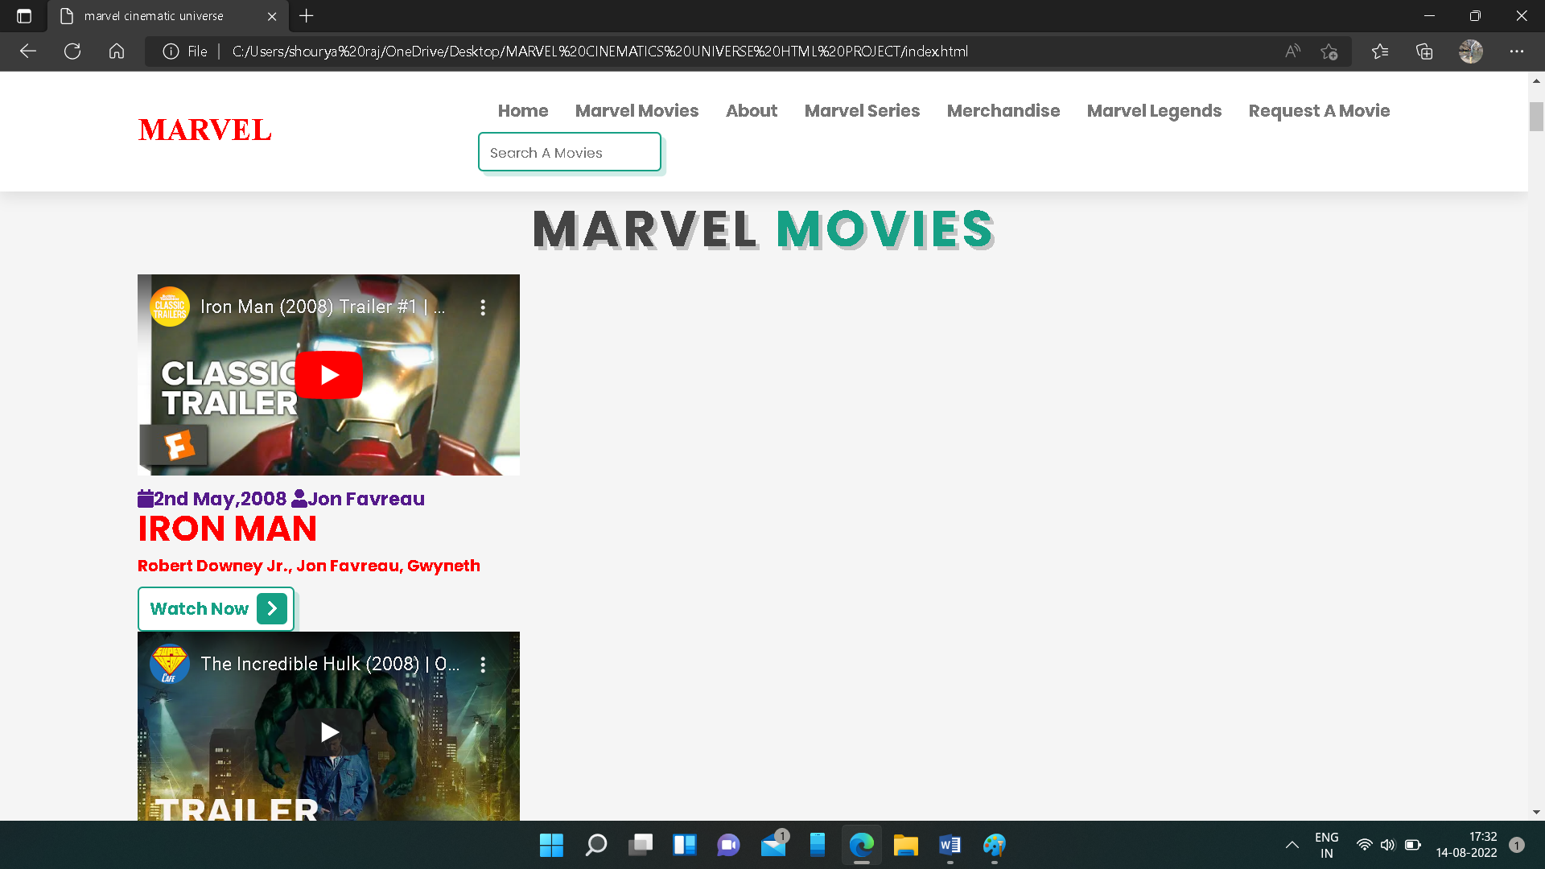

**ABOUT SECTION :**

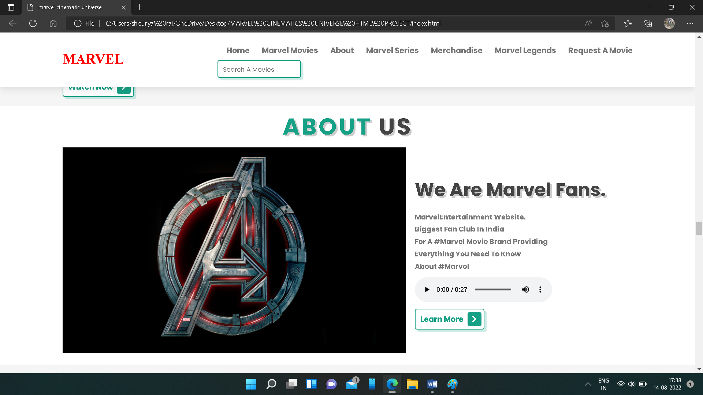

**SERIES SECTION :**

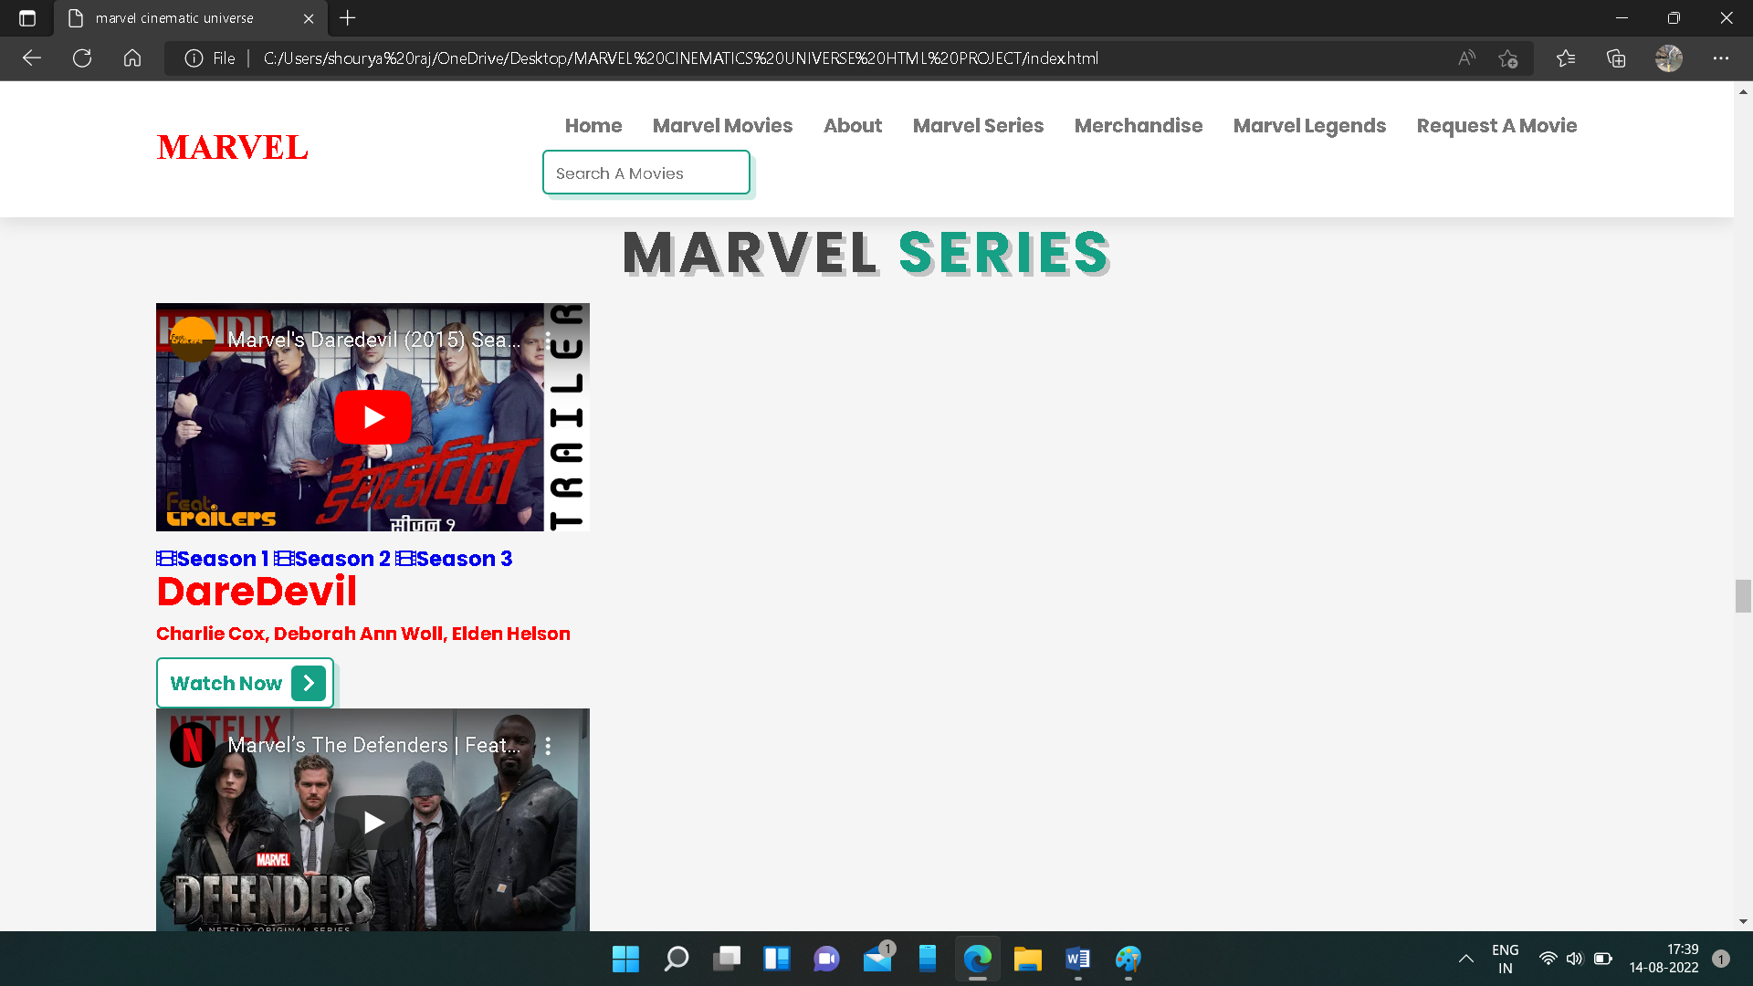

**MERCHANDISE SECTION :**

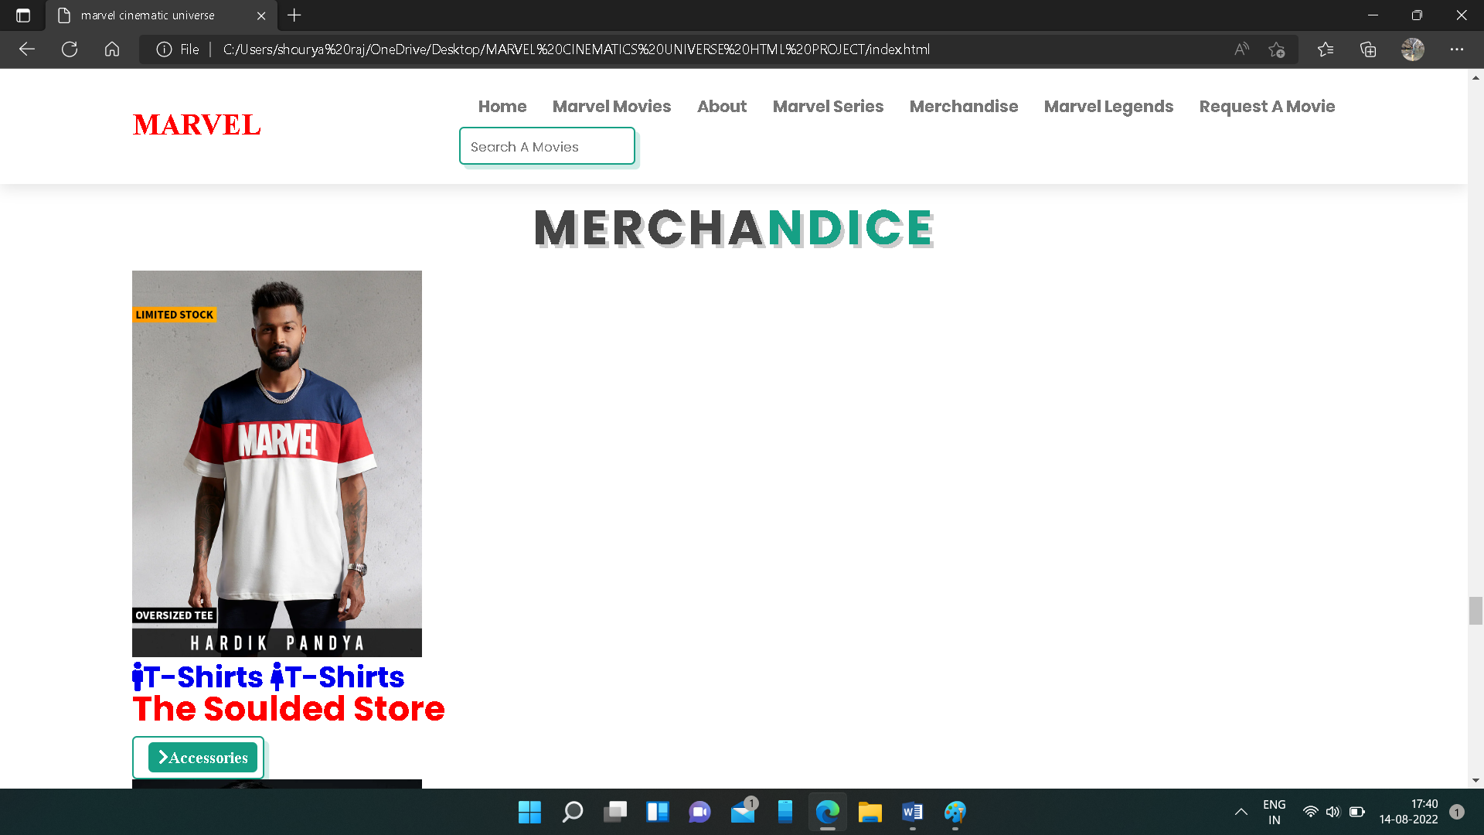

**MARVEL LEGENDS :**

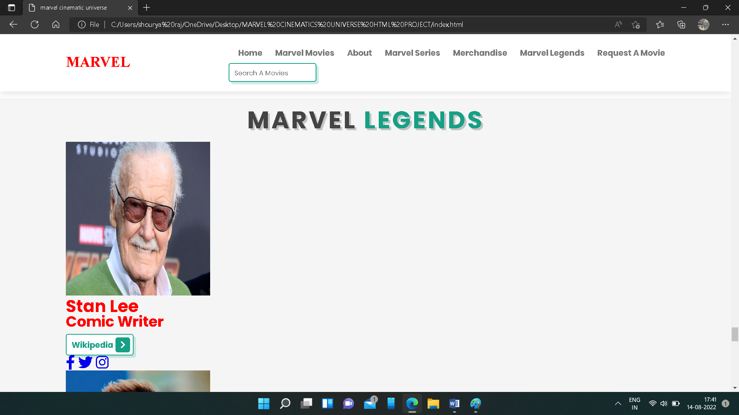

**REQUEST A MOVIE SECTION :**

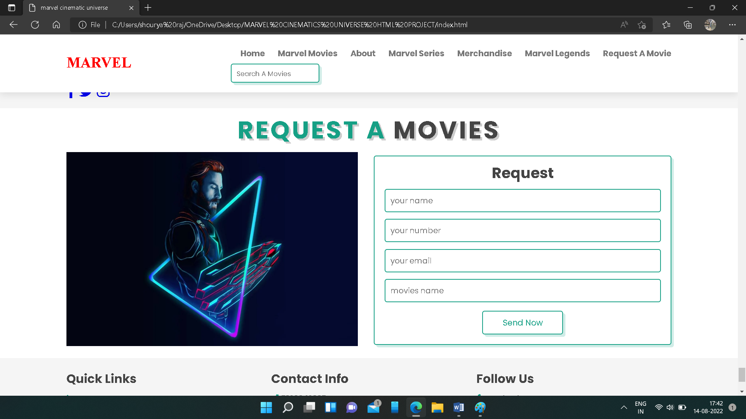

**FOOTER SECTION :**

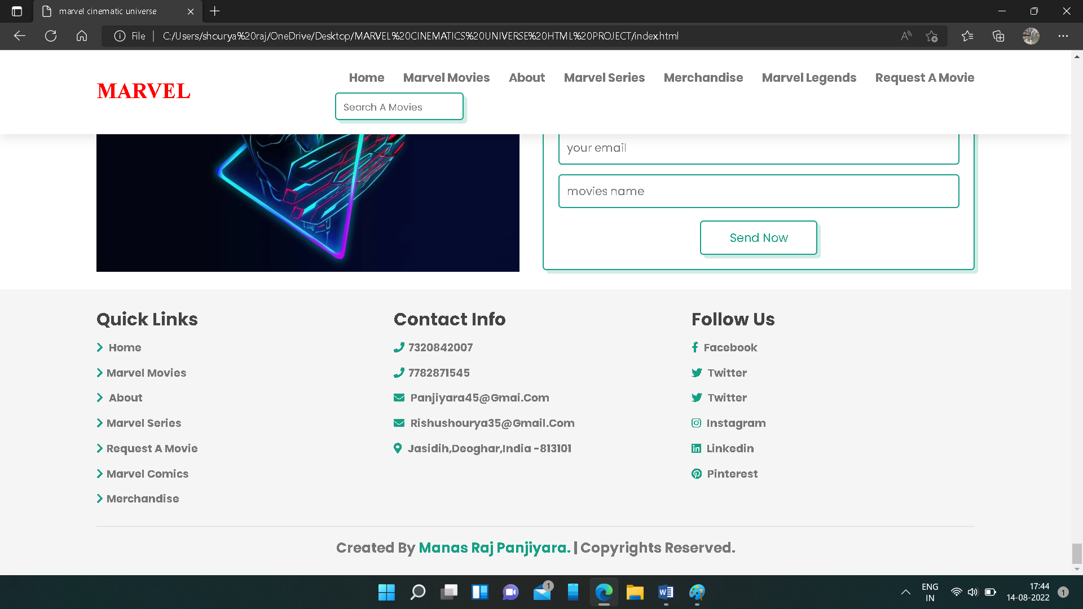

**CONCLUSION :**

Movies are made to entertain audiences, and movie websites are much the same. In order to get visitors’ attention and encourage them to see the movie, a website needs to give them what they are looking for and provide some entertainment at the same time. Today’s movie websites make it easy to take a couple minutes and watch a few trailers before deciding which movie to see.

Because the purpose of movie websites is to pique interest and sell tickets, they generally include: Plenty of video, including trailers, Easy access to show times and online ticket purchasing. Cast bios and other general info it’s important first to consider the primary purpose of movie websites. Obviously, in order for a movie to be financially successful, it needs to do well at the box office, and today many moviegoers use the Internet to find movies to see and to buy tickets. Having things like trailers and other video clips helps to engage visitors and encourages them to find show times and buy tickets online.

THANK YOU !